Day 30 - 05th Sept 2025

Saikumar pentakota

Task 01:

Create a table using AWS Management Console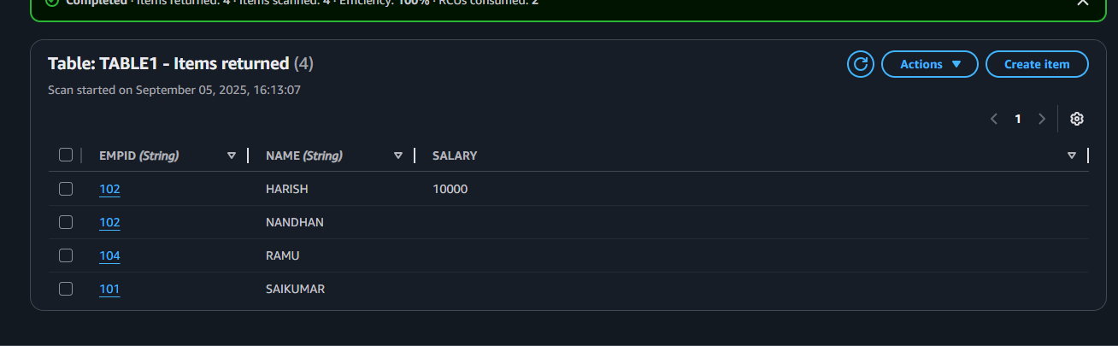

TASK2

Use all the CRUD operations using AWS Management Console.

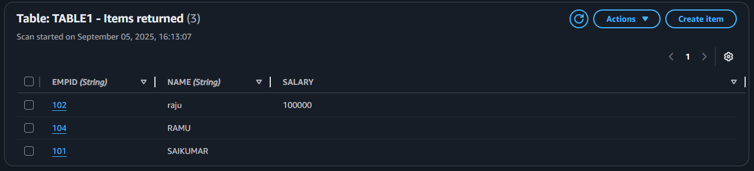

Create table

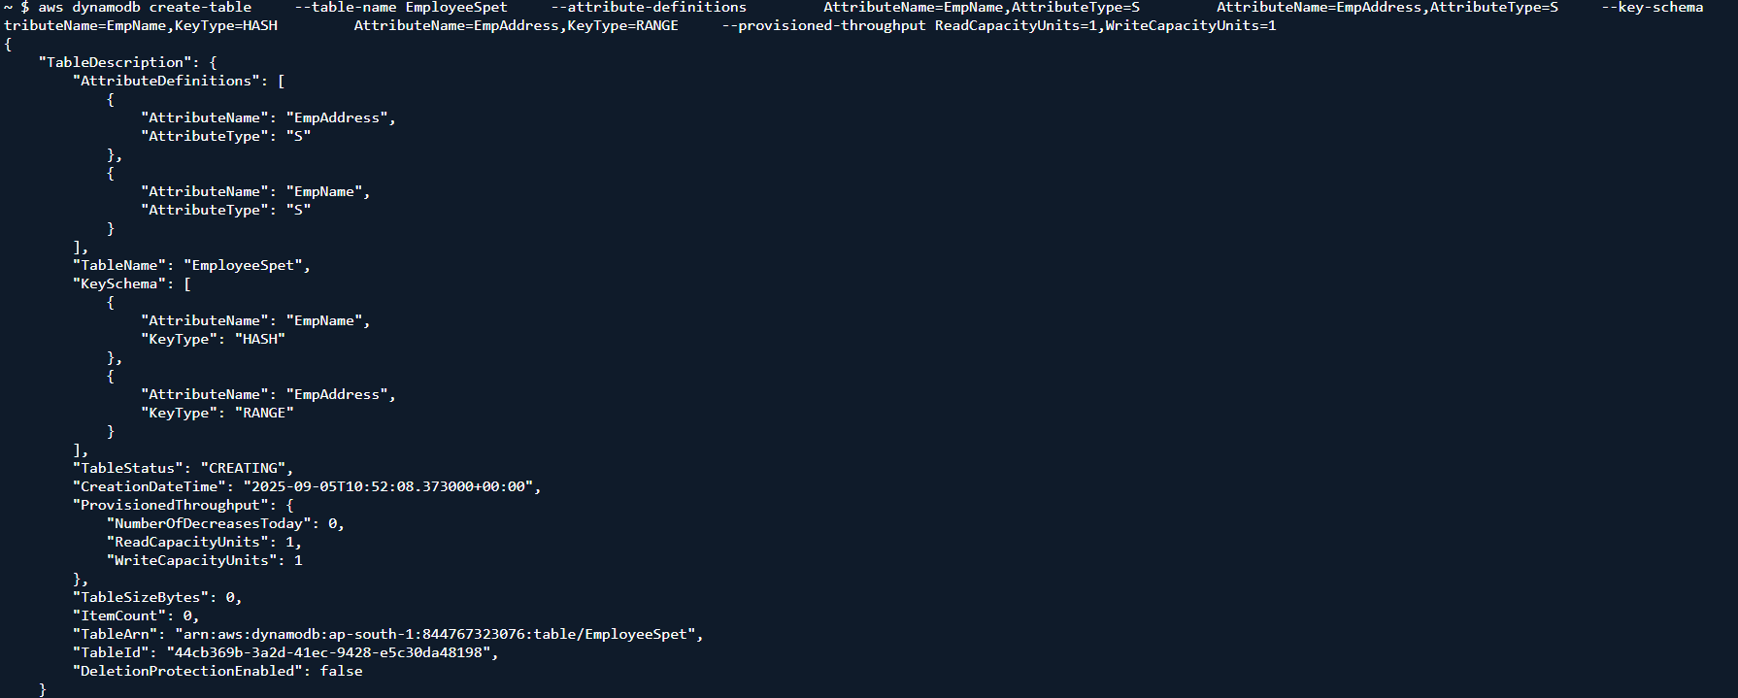

PUT iteams

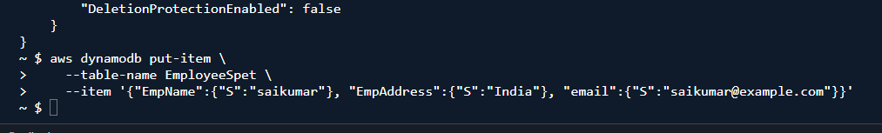

Delete a table

aws dynamodb delete-table --table-name Custtomer

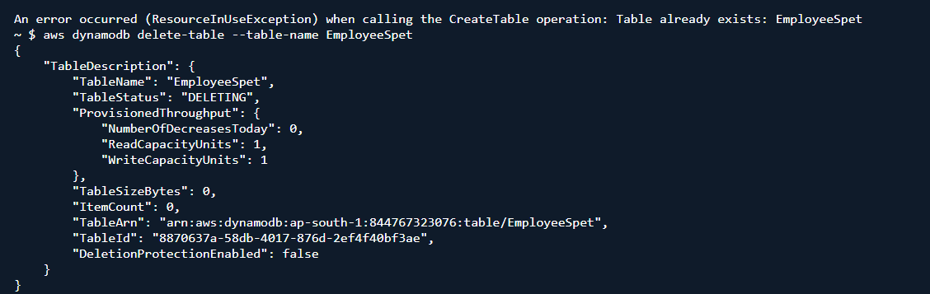

Command to show the list of tables

aws dynamodb list-tables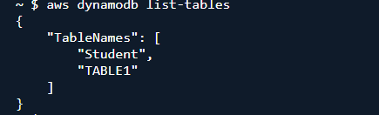

list of backups

aws dynamodb list-backups

